PROJECT REPORT

1. INTRODUCTION

1.1 OVERVIEW

**Retail management is the process of running and managing retail outlets’ day-to-day activities surrounding the selling of goods and services to customers**. It is the process that aims to make sure that customers are happy with the goods and services they purchase and that retail outlets run smoothly and remain profitable.

1.2 PURPOSE

The primary objective of retail management is customer satisfaction. Effective [planning and management](https://www.managementstudyhq.com/functions-of-management.html) will often prevent customers from waiting even when the stores are congested; as in public events, retail management will go a long way to guarantee customer contentment. Meanwhile, the retail manager’s role is to ensure that the executives serve the customers accordingly.

When the retailer keeps records of all the purchases and sales, the overall accounting is enhanced. Always track everything to make the daily calculations accurate and less complicated. By doing so, you’ll be exercising financial discipline.

2. PROBLEM DEFINITION AND DESIGN THINKING

2.1 Empathy Map

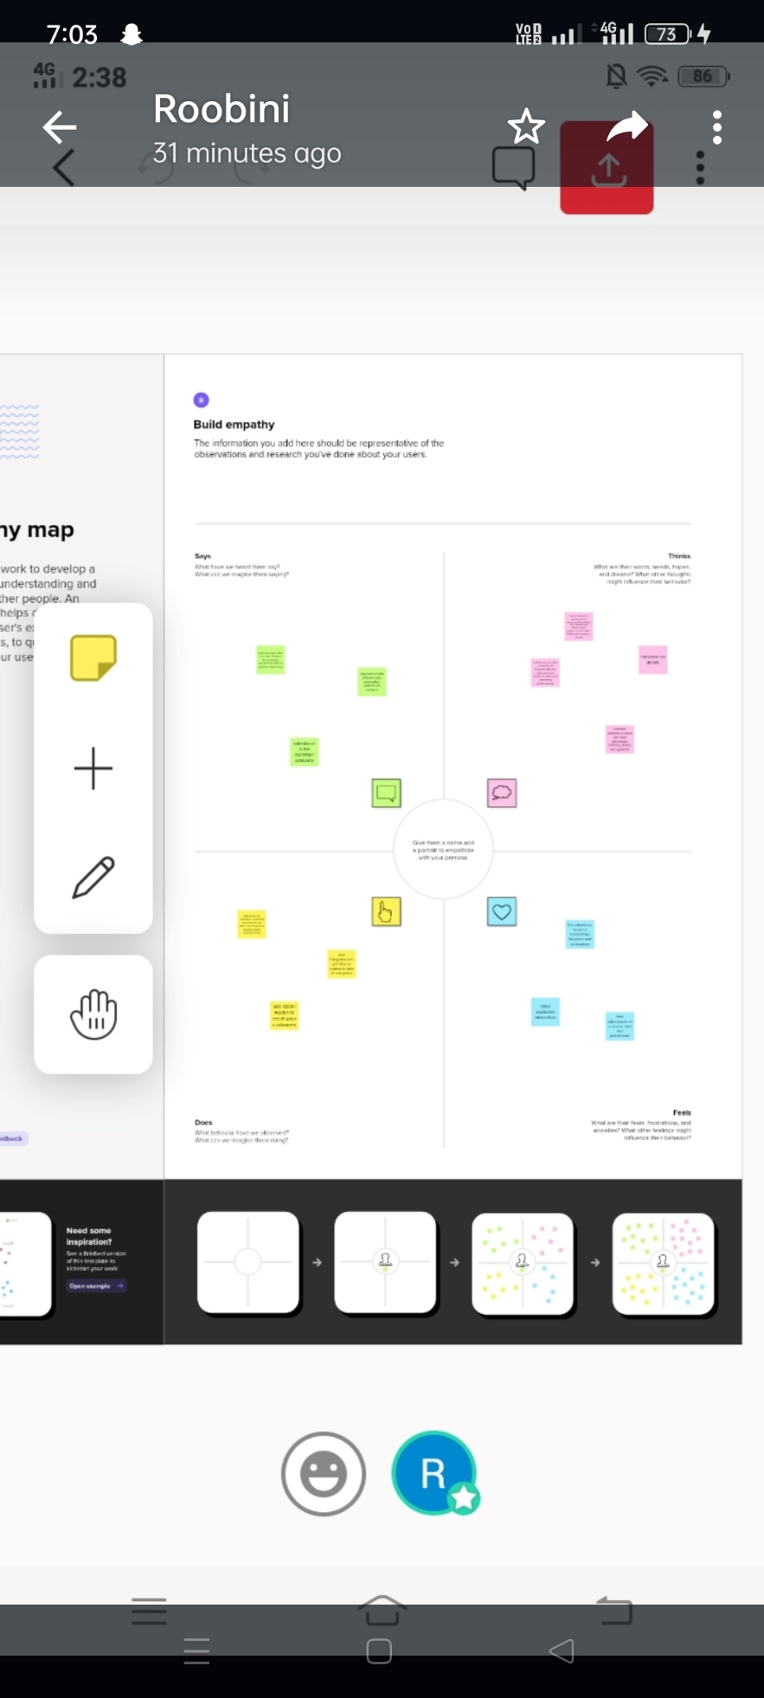

2.2 Idea thinking and brain storming

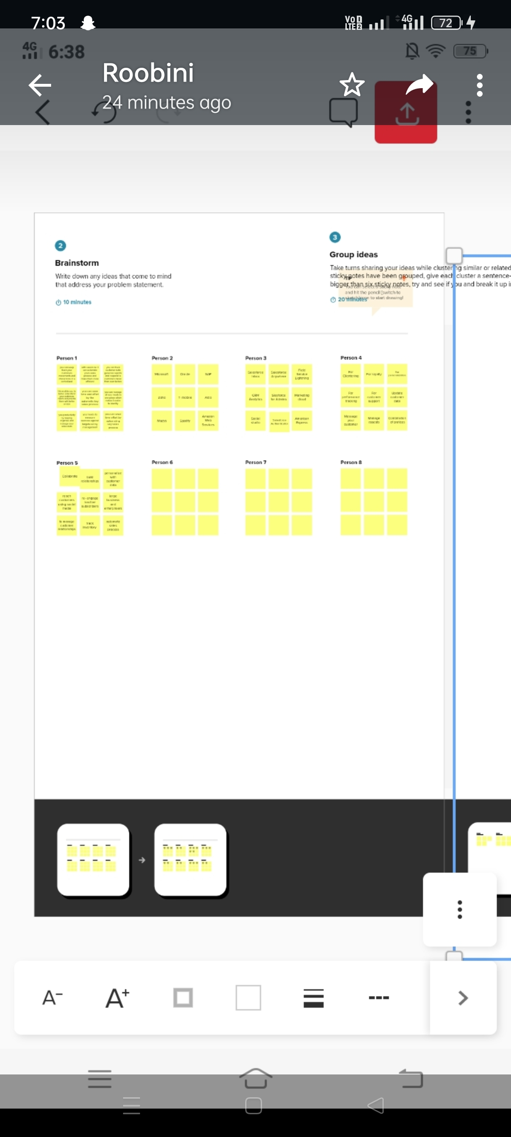









Trailhead profile public url:

Team leader: <https://trailblazer.me/id/rroobini2>

Team Member 1: <https://trailblazer.me/id/sabarianandham>

Team Member 2: <https://trailblazer.me/id/skala340>

Team Member 3: <https://trailhead.salesforce.com/today>

ADVANTAGES

* Customer satisfaction The biggest advantage of retail management is customer satisfaction. ...
* Hassle-free shopping It helps the customers to find all the products easily in the store. ...
* Prevents unnecessary chaos and shoplifting activities Proper Retail Management prevents a lot of unnecessary crowding and chaos in the shop. ...
* Proper accounting ...
* Well-organized store and inventory management

DISADVANTAGES

* Inadequate capital is always a big problem to their trade.
* No room for expansion due to lack of enough capital.
* Inability to enjoy economies of scale.
* Do not easily obtain loan.

Conclusion

Retail Management and its Importance Whether you have a small shop or a mega store, if you own a retail business, then**retail management is a must to run it effectively and efficiently**. From the above discussion, we can realize the importance of retail management. It helps retailers save time and gain customer satisfaction.

Future scope

Retail management has become one of the fastest growing career in the industry with the tremendous growth in the economy. Retail Market of India is the most attractive and emerging market in the world and has demanded more number of trained professionals in this field.

It strives to create a new generation of smart retail professional of international caliber and aims to equip them with the best practices being followed across the globe.